Clarification:

**For this assignment, we used K-means as our initialization.**

* trees ie2cf92c40c3f3306321d789f7e9c12893.jpg - segmented into 10, 20 and 50 segments
  + 10 segments:

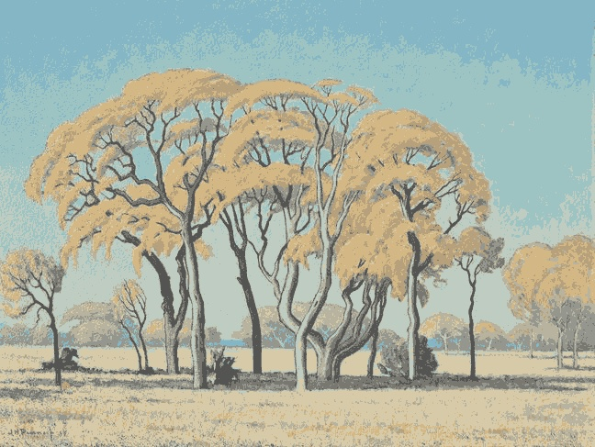

* + 20 segments:

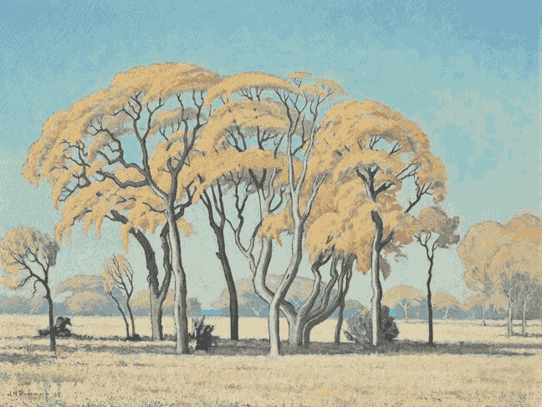

* + 50 segments:

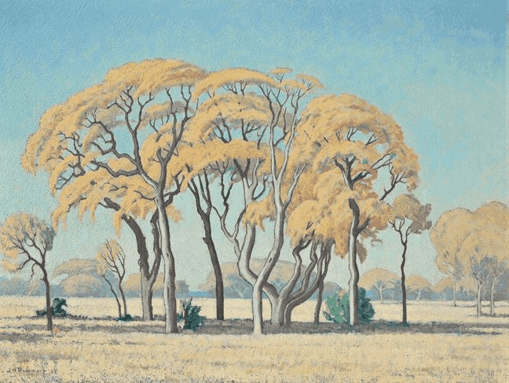

* RobertMixed03.jpg segmented into 10,20,50 segments
  + 10 segments:



* + 20 segments:

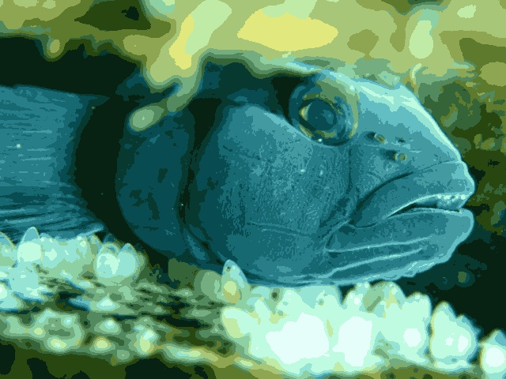

* + 50 segments:

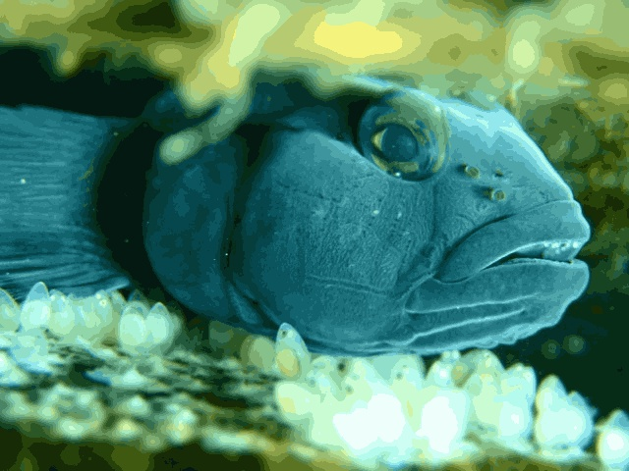

* smallstrelitzia.jpg segmented into 10, 20 and 50 segments
  + 10 segments:



* + 20 segments:

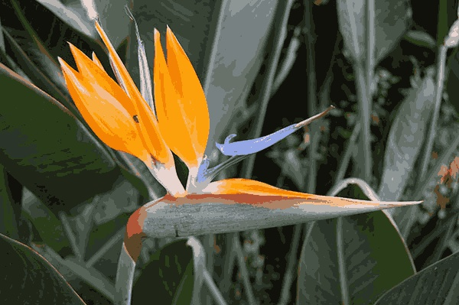

* + 50 segments:

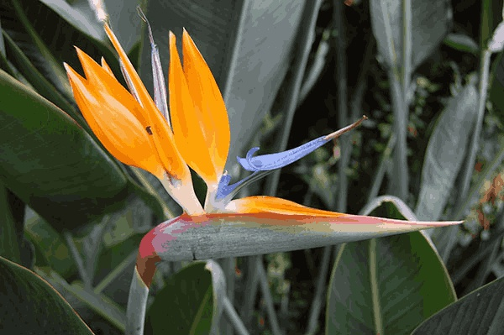

* smallsunset.jpg segmented into 10,20 and 50 segment
  + 10 segments:



* + 20 segments:



* + 50 segments:



Display of tree image with 20 segments with 5 different initial points

Set 1 of initial points: Set 2 of initial points:

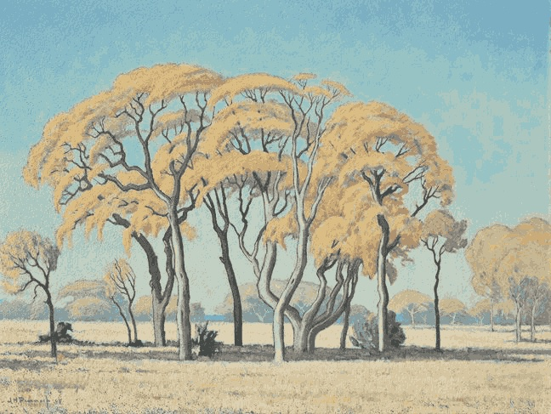

Set 3 of initial points: Set 4 of initial points:

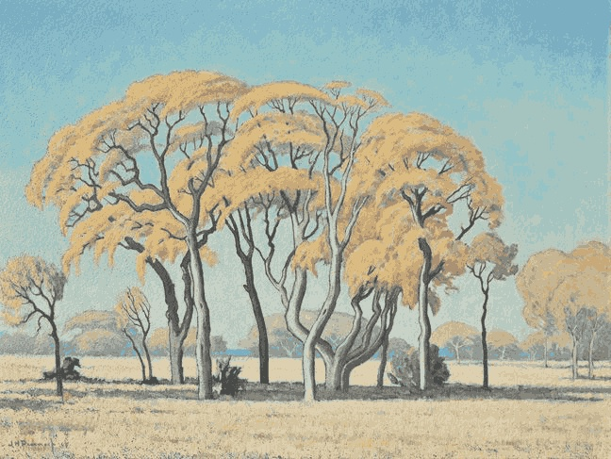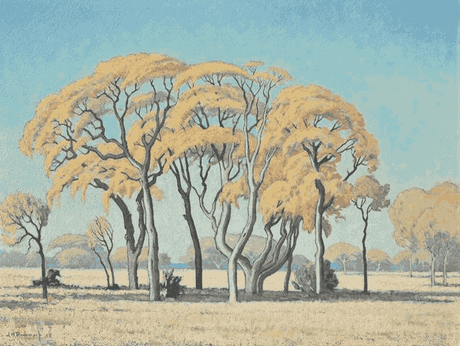

Set 5 of initial points:

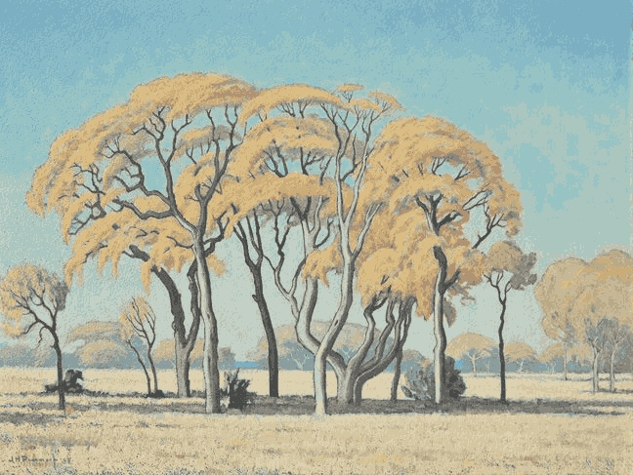

* Code snippets for EM initialization, updates

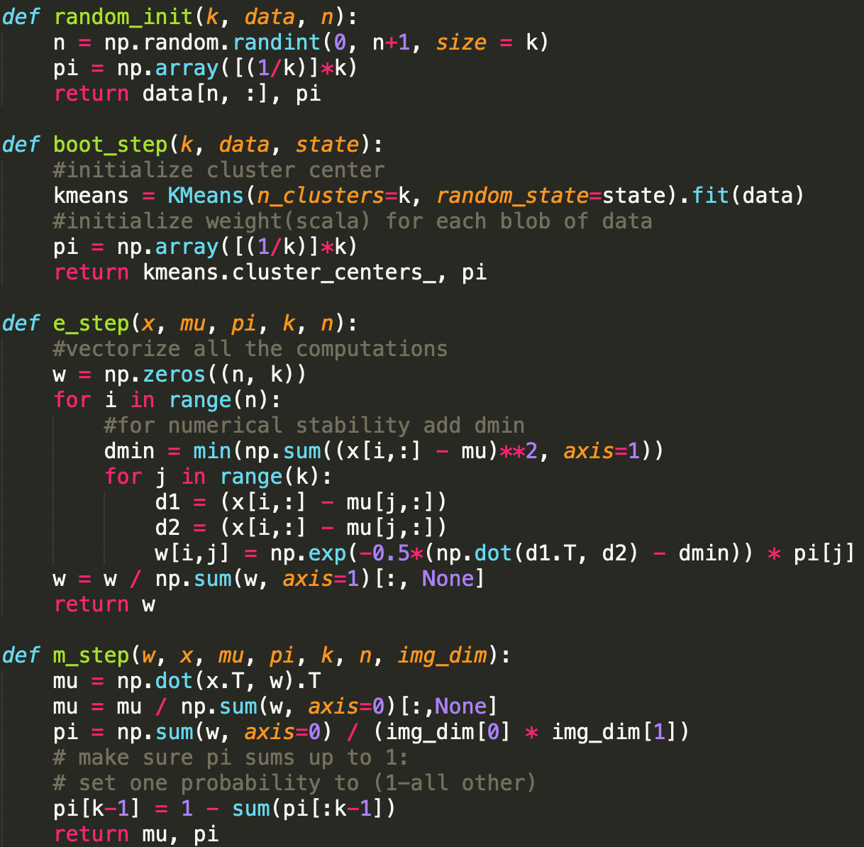

* Other relevant code (optional) 